Apress LightSwitch 2012 by Tim Leung – Chapter 14

This chapter shows you how to create reports.
This solution contains two projects: an ASP.NET project that contains reports, and the LightSwitch project.
To run this solution, you’ll need to modify the database connection string in your ASP.NET project so that it points to your LightSwitch project’s Intrinsic database. To do this, open the web.config file for your ASP.NET project. You’ll find this file in the following location:
HelpDeskVB\HelpDeskPortalVB\HelpDeskPortalVB\Web.config
Open the web.config file in notepad and find the following connection string.
<add name="HelpDeskVBConnectionString" connectionString="Data Source=(localdb)\v11.0;AttachDbFilename=C:\Source\Chapter14\HelpDeskVB\HelpDeskVB\bin\Data\ApplicationDatabase.mdf;Integrated Security=True" providerName="System.Data.SqlClient"/>

Modify the path that’s highlighted. Once you’ve made this change, you can run the HelpDeskVB or HelpDeskCS solution. When you run one of these solutions, Visual Studio hosts the ASP.NET HelpDeskPortal site using either IIS Express, or the built in development web server. In either case, you can find out the URL for the HelpDeskPortal site by looking at the icon that you’ll find in the notification area. In this case, the root address is http://localhost/57290.
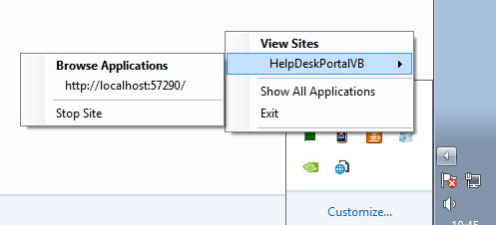

When you run the HelpDesk application, open the ‘App Options Edit’ screen and check that the Report Server textbox contains the correct root address, followed by the path ‘/reports’. This setting ensures that screens in the application point to the correct place.
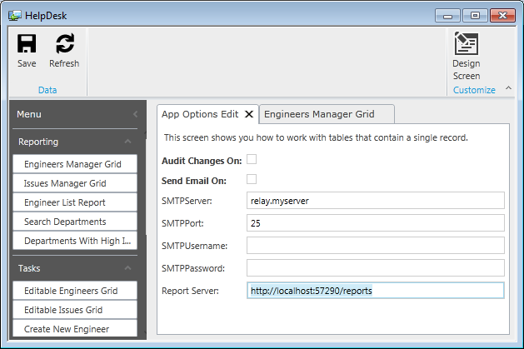

This application also includes an example that shows you how to generate PDF documents using a library called SilverPDF (http://silverpdf.codeplex.com/). If the HelpDesk project fails to compile, check that your Client project includes a valid reference to the silverPDF.dll file. You’ll find a copy this file in the folder \DLLs\silverPDF

Tim Leung

